Homemade Fermentation Lab
The main objective of this experiment was to makes 1 gallon of homemade alcohol, sometimes referred to as moonshine, with an alcohol content of approximately 40 percent.
Ingredients:
- 28 g sugar
- 0.5 cup of water
- 1/3 teaspoon baking yeast
Procedure
Before starting to make alcohol at home, I made sure to properly sterilize and clean all the storage containers and utensils by using boiling water or wiping them down with isopropyl alcohol. This crucial step helps prevent unwanted bacteria from contaminating homemade alcohol recipe.
In a large saucepan over high heat, I boiled water then turned the heat to low and added the sugar. Using a wooden, nonreactive spoon, I stirred to dissolve and form a sugar solution. Then removed it from heat and let it cool to room temperature. I then added the baking yeast and stirred well to combine. Then transferred it to a glass jug with a small mouth like a carboy with an air lock and filled only up to 3/4 of the jug’s entire volume to leave space for the fermenting liquid to give off bubbles of carbon dioxide.
I then stored the jug in a dark, warm room for the duration of the fermentation process. Shook the jug to give off excess carbon dioxide for 45 to 60 seconds twice a day without removing the airlock. The homemade alcohol will took anywhere from 3 to 10 days to be ready. To know that there is no more carbon dioxide fizz, I smelled the alcohol, and sediment had also settled to the bottom of the jug.
I then strained the homemade alcohol and transferred it through a thin tube to a large, nonreactive saucepan over medium heat then heated until to 122 degrees Fahrenheit – this kills any remaining yeast and lets off the remaining carbon dioxide.
To distill the ethanol out of the mixture I used the distillation of water technique by: Decanting the liquid in the Mason jar by making sure that the jar is submerged in water at the heating level to medium low for distillation of the ethanol and the stopped the reaction when there were about 8 oz. of liquid
Letting the sugar solution come to room temperature before adding the yeast is important so as not to kill the active yeast by high heat.

Homemade Alcohol Variations
Once you have the fermentation process down, experiment with making alcohol at home by using a different source of sugar. Fruit juice or whole fruits like berries, peaches and grapes all make for perfect sugar substitutes.

Observation and explanations
When using baking yeast, the mixture overflowed but thanks to the tip, adding a few cracker crumbs to prevent this from happening.
On fermenting the liquid, the solution of water and sugar was converted to ethanol and carbon dioxide. Release of gases proves that carbon dioxide was produced. Yeast plays an important role of fermentation.
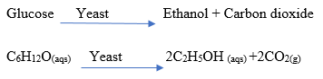
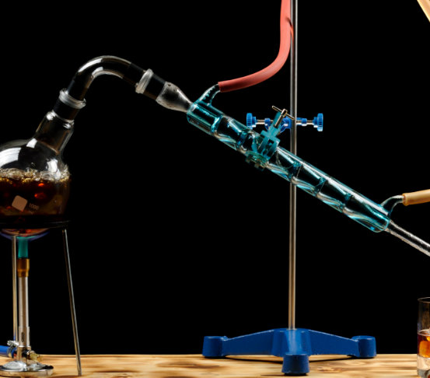
This is fractional distillation, it separated alcohol from water. Fractional distillation relies on the fact that different compounds have different boiling points and therefore since ethanol has low boiling point, it will vaporize faster than water. Therefore alcohol vaporizes which is then cooled by cold water into liquid form.
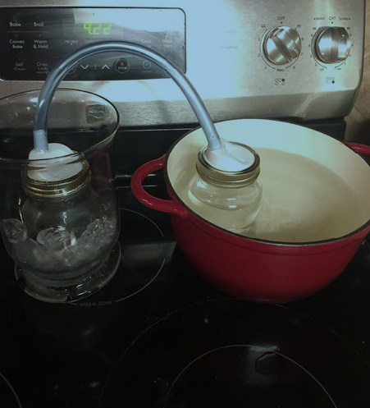
The vaporized ethanol is cooled by the cold water/ice into liquid form.

